SIXTH FORM INDUCTION PROGRAMME BEGINS

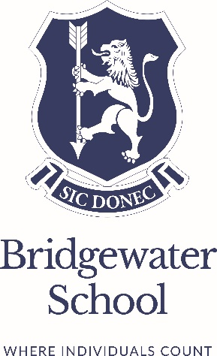
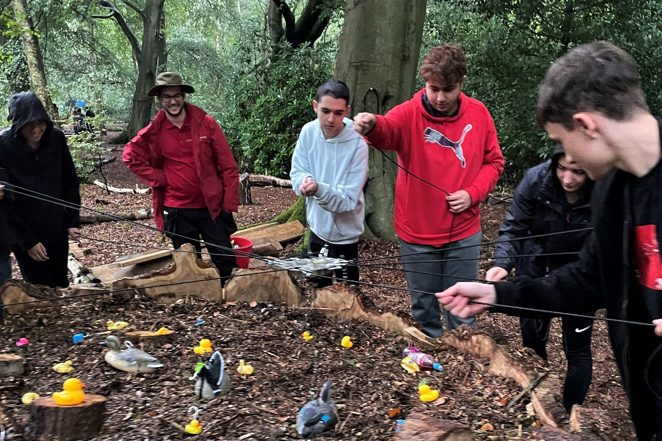

As our Sixth Form students discovered on their team-building day at the start of the new term, a spirit of independent thinking and successful collaboration is key from day one.

Sixth Form is a major period of exploration and discovery, with students encouraged to build strong, rewarding relationships with teachers and peers alike. An inclusive induction programme provides for a seamless transition into Sixth Form and begins with a unique bonding experience designed to develop initiative and critical thinking skills, and help our students learn to achieve together and be part of a team.

This year’s team building day, held at Adventure Now, saw sixth formers work together to complete a variety of outdoor activities including rifle shooting, archery, axe throwing, bushcraft and problem-solving challenges, and paves the way for a successful and fulfilling journey through their A-level studies.

