HARVEST FESTIVAL CELEBRATES COMMUNITY

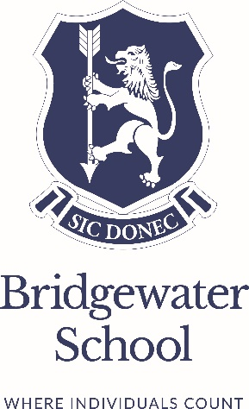


This autumn, our Prep Department’s annual Harvest Festival once again brought the school community together in a meaningful celebration of generosity and gratitude. With the support of our Bridgewater families, an impressive collection of food items and beautifully arranged Harvest baskets were donated to Salford Loaves and Fishes, a local charity dedicated to supporting the homeless, isolated, and vulnerable individuals within our community.
A selection of these Harvest baskets, generously filled by families across the Prep Department, was presented at our Harvest Festival service held at St. Mark’s Church. The children gathered together, performing and giving thanks, while also reflecting on the importance of helping others.
The Harvest Festival highlights Bridgewater’s commitment to inclusivity and community spirit, values that are fundamental to our ethos. Events like these reinforce the importance of giving back and making a positive impact on the lives of those around us, encouraging every student to take an active role in nurturing a compassionate and inclusive world.

